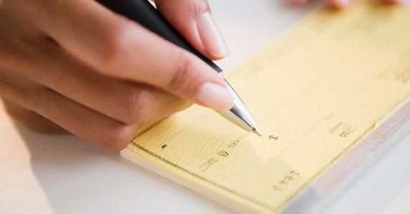
Checkbook Spelling Homework
Number | Write out number | Number | Write out number
1 |  | 18
2 |  | 19
3 |  | 20
4 |  | 30
5 |  | 40
6 |  | 50
7 |  | 60
8 |  | 70
9 |  | 80
10 |  | 90
11 |  | 100
12 |  | 1,000
13 |  | 1,569
14 |  | 5,985
15 |  | 10,981
16 |  | 4,091
17 |  | 8,415

Write this check to Clare High School for $35.42 for a Pioneer sweatshirt (use today’s date.)
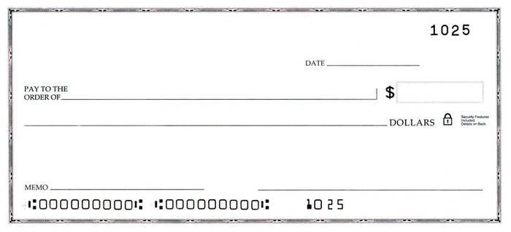

How many days are in: November _____, March ______, April _____, December ______, September _____

